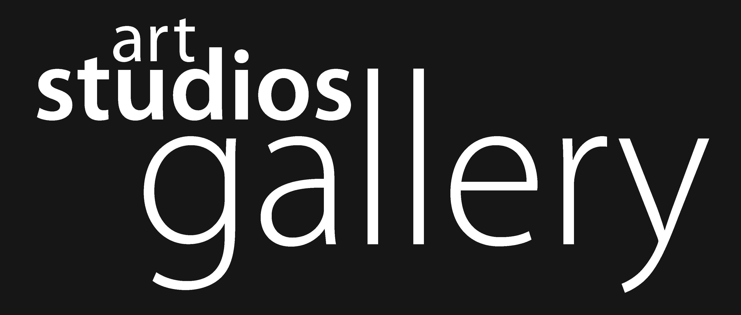

post or email to: Art Studios Co-operative Limited
391 Mann St Gosford NSW AUSTRALIA 2250
02 4339 3349 artstudioscooperative@gmail.com
www.artstudioscooperative.org
Open Wed to Fri 11 - 4
Sat / Sun 10 - 4

Exhibition PROPOSAL
(use separate form for each Artist For Group ExhibitionS)

Your Name:
Names of other artists involved if applicable:

Your Address:

Email:

Phone M H

Website:

Preferred exhibition dates (refer to our website for current availability):

Availability to man exhibition (15% discount if artist(s) man exhibition themselves):

Availability for artist talks during the exhibition:

Exhibition Title:

Brief statement discussing your proposal (approx 150 words):

2D / 3D / Video (please indicate):
Media incorporated:
Approx # of works:
Approximate sizes:
Special requirements (equipment / hanging):
Artist CV (Include or attach exhibition history and general statement about your art practice):

Include or attach 10 images related to the exhibition proposal of work produced in the last 2 years (1mb or smaller).
*Name files per: lastname_firstname_title_pxwidth_date.jpg

*By submitting this proposal, I hereby acknowledge that I allow Art Studios Cooperative to use images of my work for promotional purposes only, and that I will provide images and information when required.
*PLEASE ALLOW 1- 2 weeks turnaround time for email correspondence regarding your proposal.

